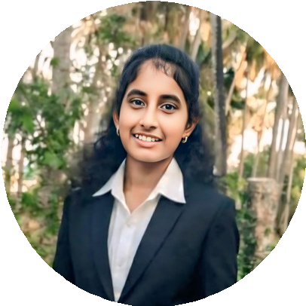
BALAGOPIKA L
MASTER OF COMPUTER APPLICATIONS
(PURSUING)

ABOUT ME EDUCATION
Master of Computer Applications (MCA) student with a strong foundation in Computer Applications and basic knowledge of manual testing and front-end technologies. Familiar with HTML, CSS, JavaScript, Python, and C programming.
A quick learner seeking an internship opportunity in the IT industry to gain hands-on experience, contribute to software quality and development, and strengthen technical skills.

Anna University
Sri Venkateswara College of Computer Applications and Management, Coimbatore (AICTE approved)
Master of Computer Applications (MCA) || 2024 - 2026 ||
Mother Teresa University
Government Arts and Science College for Women, Kodaikanal
Bachelor of Computer Applications (BCA) || 2021 - 2024 || completed with 80% of overall score.


CONTACT PROJECT
- Manual Testing – Demo Web Shop (Tricentis)
- Created traditional & BDD test cases
- Prepared RTM and executed test cases
- Logged and tracked defects, documented results

+91 9042503812
Nethaji Street, Rettaiyurani,

Ramanathapuram 623534

balagopikaloganathan@gmail.com
Balagopika L
TECHNICAL SKILLS
- Languages: Python, C, JavaScript
- Web: HTML, CSS
- Database: MySQL
- Tools: Jira, VS Code, MS Office & Canva
- OS: Windows
- Logged and tracked defects, documented results
LANGUAGES
- English
- Tamil

SOFT SKILLS DECLARATION
- Adaptability
- Teamwork
- Communication
- Time Management
I declare that all the details mentioned above are true to the best of my knowledge.

